**CaptainVR Handleiding – Sophie de Groot**

## Projects I’ve Worked on

### CaptainVR Metaverse (Altspace And Mozilla)

AltspaceVR Maze Runner 1

Maze Runner 1 was made to call in all the fears you might have. By facing your fears you will stimulate leadership and make it clear you have what it takes to face a challenge. The secret text is placed within the well, which you can see by picking up the light next to the angel.

AltspaceVR Maze Runner 2

Maze Runner 2 is about climbing a tall mountain. You can climb this mountain by teleporting or ‘using your spider powers’. This world first started as a hangout world where you had to climb the top, later remade to fit in the Maze Runner theme. This world doesn’t use custom made models and only features the kits within AltSpace. The secret text is placed behind the waterfall.

AltspaceVR Maze Runner 3

Maze Runner 3 is about guiding your team AT the top as opposed to maze runner 2. You have to walk thin planks, and don’t look down! This world contains custom models such as buildings, cars and smaller props. The secret text is placed on a laptop screen in the office building to the right of spawn.

AltspaceVR Maze Runner 5

Maze runner 5 is about presenting yourself in less than 5 minutes. Using the standard altspace presenting room preset we added custom models such as Characters, Confetti and smaller props.

Mozilla Hubs CaptainVR ruimte

Containing custom models and images this room was created for the captainvr meeting room. Here you can view the people through camera’s as if you were there.

Mozilla Hubs Expo Center

The expo-center is supposed to be a big center for people to present in booths and to view products and services of each company featured in the center.

### Climbing Wall

Climbing Wall level 1

This level plays outside on flying rocks, high in the sky. This game was made to get people more active/energetic while working. Climbing wall level 1 features objects such as the base level, climbing rocks, climbing triangles, triangle pads, checkpoint flags, wind particles, a sun, a waterfall and smaller props.

Climbing wall is supposed to be played with multiple people online. The project uses Photon for the multiplayer service. You were supposed to be able to change color to distinguish yourself from others, but we weren’t able to finish that in time.

Climbing Wall level 2

Climbing wall level 2 has the same meaning as level 1. This time you’re in space. This level features objects such as the base level, climbing rocks, modified checkpoint flag, arrows, climbing triangles, stars, planets, a sun and smaller props

### Synchronised Breathing

This game is made for people who want to relax and lay a focus on their breathing. I made the animations for the scenes: Section 1-5 and Synched Breath. This game is still unfinished as a matter of fact. It still needs some code for the breathing indicator and for collision with UI and exiting the experience when you want to.

### Sociale Angst

Sociale Angst is an app created to help your pitches and speech when your up against a business. I made the art assets for the dragons den and the elevator pitch.

### Dream Runner

Dream runner was supposed to be a game for activity on the workplace. We decided to focus on Climbing Wall since it had the same purpose. I did make some art assets for the game but there is a large portion that’s still left unfinished.

### Geluks Maze

Geluks maze is a project made for stimulating happiness and focussing on the positive things of life. There are several sections which are still empty but most sections are easily accessible and themed. Each room is supposed to stimulate some kind of happiness in a way. You spawn on a cloudy platform with in front of you, a flower pot and a tree root growing from behind it. If the player follows this tree root accordingly, they will successfully finish the maze.

## Unity/AltSpaceVR Problems

### Unity doesn’t render both faces of your plane.

In the material assigned to this plane change the “Render Face” option box to ‘Both’. The default for this setting is ‘Front’ so be aware.

### Unity Transparent planes have the same render layer

This is fixable in two ways: first way can only be applied if you’re using a cutout texture. Otherwise I recommend making a cutout texture if you can. You have to pick the shader: UniversalRP> Autodesk> AutodeskMasked. This shader is the best way to have full optimization over your material. Second way is by duplicating your faces in your 3D-program and reversing the faces. In Maya this can be found under Mesh display> Reverse. Then get a lit shader and assign your transparent texture. Make sure the render face is set the front, and you’re all set!

### Github keeps saving your project to the wrong folder upon creating a new branch.

So the way Github works is that when you have Github desktop open, it will automatically change the branch your currently on to whatever Unity scene you have open/are opening. So in my case I had both Unity projects saved on the same folder. Fixing this issue is quite simple. Just create a new Unity scene in a different folder, move all your assets there from your files library and when you’re sure everything is on the new one, delete the old one.

### Importing animations to AltSpaceVR

It may sound simple but it was pretty confusing for me at first. So here’s the deal, it really depends on wether your game object is rigged or not.

If it is rigged you should follow these simple steps: First go to the “Animation” tab in your game objects inspector view. Here you should make the animation clips for your rigged object. Then make sure your animation is on looped mode. After that you go to the “Rig” tab. Assign the right rig to your model with an Avatar. You can do that under ‘Generic’ or ‘Humanoid’ by changing the box that says “Avatar definition” to ‘Create from this model’. Then you can select your rig and click apply. Lastly create an animator controller for this model. In the animator make a transition from the start into an empty state. In this empty state you want to specify your animation clip. After that you’re done.

If it’s not rigged it’s fairly easier. Make your animation clip in the “Animation” tab of your game object. Set the object to loop mode. Then in the “Rig” tab select ‘legacy’. Default settings should do fine! Lastly create an animator controller for this object in your project folder. Inside the animator controller, make a transition from the start into an empty state. In this empty state select your animation clip of your object. That should be working now.

Still doesn’t work? Try looking for the “Animation” tab again and double check if looped mode is enabled. If you place your game object in the scene, does it have an animator controller component connected in the inspector? If not then create one yourself and that’ll do it. Try changing the rig type. Or if that still doesn’t work out, look for any bugs on this topic on the internet.

### 3D sound settings for AltSpaceVR

I had some trouble getting the sound just right in Altspace. So if you have your sound in your scene, the first thing you should check is if it isn’t accidentally assigned to a game object. If you want to setup a good surrounding sound you should follow these settings I’ve setup for you:

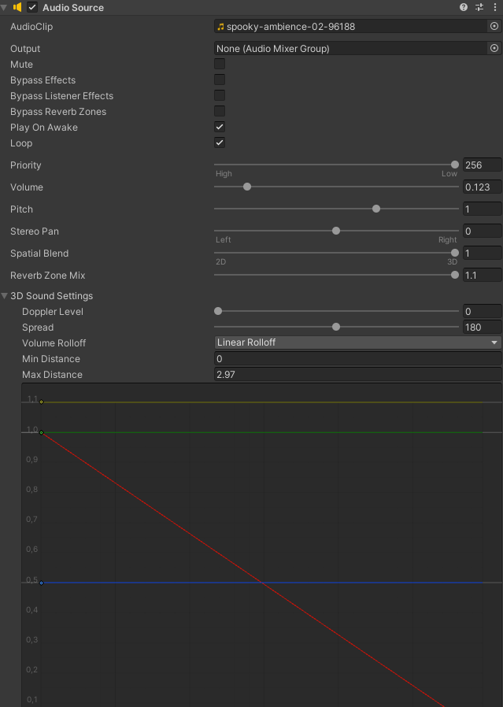

### Export kits/templates to AltSpaceVR

First make sure you have the right Unity version installed. You will need to install Unity 2020.3.18f1. Make sure to select the Android, Mac and Windows package when downloading this version. Just create a Unity project in this version as a Universal RP and follow these next steps.

In the Package Manager, click the little plus icon and select ‘Add package from tarball…’. Then select the AltSpaceVR Uploader which you can download [here](https://aka.ms/AvrUrpUploader). When installed it’ll give you a new tab named ‘AltSpaceVR’. From there you can export any kits/templates to your AltVR account.

Next up is an explanation about kits and templates.

Kits:

Kit items can only be exported as prefabs. These prefabs (kit items) can be exported to any kit you prefer. The only way to create kits is via the AltVR website. There in the ‘More tab’, select kit to view kits. You can convert any game object instantly to the kit by clicking the ‘Convert game-object to kit prefab’ button. This will delete the model from your scene and move it to your prefab folder. It will then automatically move it to your kit. By pressing build and upload your kit will be uploaded with the specified kit items. If you do this in a different scene it cannot complete the complete upload because it’s missing the other kit items, Just simply move the prefab from your other project to the new one to include it in the kit export.

Templates:

Follow the first few steps in the kits explanation. You should have the AltSpaceVR uploader now. Preferably you want to export templates to the CaptainVR account, so ask Dana-Maria for login data for this account. This is because if you delete your account on altspace the templates will get deleted. So it’s just a safety measure. Templates can only be exported as Unity scenes. You can only create an empty template on the website. You need to export your Unity scene into this empty template. You can select your template in the unity AltSpaceVR uploader and also select your Unity scene. Don’t forget to place colliders on every object so you can’t fall through the scene in AltSpaceVR.

**Important template info:**

Every object is assigned the default layer by default. Setting this to the NavMesh layer will make this object teleportable in AltSpace! 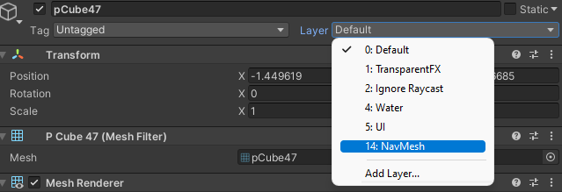

In the export options, turning Auto-manage layers on will turn every game object to the NavMesh layer making them all teleportable. If you want to prevent the player to teleport turn this off!

### Performance issues in AltSpaceVR

If you’re experiencing lag in your AltSpace world, it’s most likely particle systems, Shaders or high quality textures. Make sure to compress textures to a lower quality to ensure they aren’t 5 mb or more. Particle systems take up a lot off space in your world. Optimizing them is rather easy. Make sure the emission is set low but try to mimic the effect with as little particles as possible. Shaders should not be too extreme as well. Constant flickering or even a water shader can highly damage your fps in AltSpaceVR.

### Shadergraph tips

Shadergraph is an amazing tool for creating shaders without coding! But there are still some bugs ofc so I’ll cover what I came across.

The ‘scene-color’ node isn’t rendering! This has to do with your Universal RP settings. Make sure that in your Universal RP settings the ‘opaque’ checkbox is turned on. The ‘depth’ checkbox should also be enabled if you’re working with the ‘scene-depth’ node!

Moving an object when you’re near the object is hard to do in shadergraph! There are almost no good tutorials as to how to do this. Since code isn’t allowed in altspace I’ll go over how to replicate this effect. Many results ended up in the object scaling. But putting this in the vertex position, will move your object: 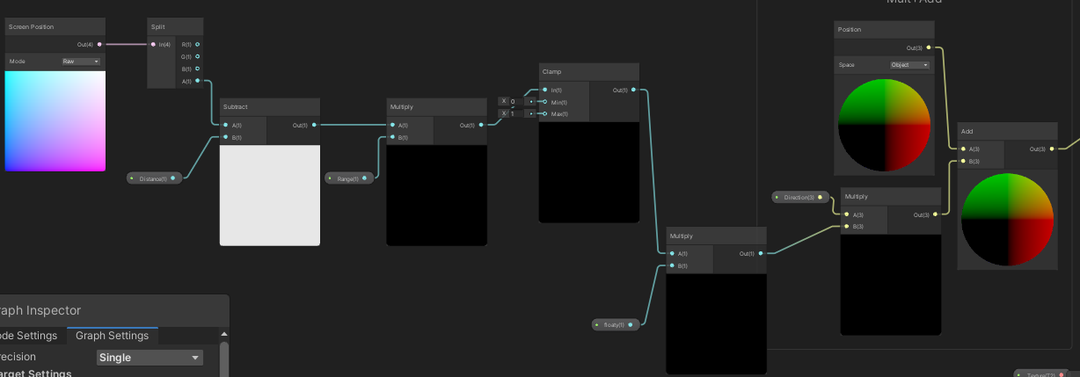Just make sure to add the right properties! The Distance Property is to calculate how far you are away from the object. For me it’s on 3.95. The Range property is multiplied by this number so you have more control over the range you’re camera is in. I have it on -0.5. The empty float is the falloff, which in our case is not necessary. For me it’s on -5. The direction property is a vector 3 to move the object in that direction. The direction is in world coordinates.

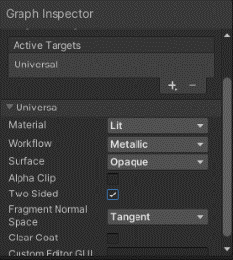If your wondering how to make your object two-sided if it’s a plane, just turn on this checkbox in the graph inspector:

### Code Scenemanager.loadscene doesn’t work on button.

By adding a button component to an object, you can determine what function it has. You can even get it to run a script that’s attached to this gameobject. I had a button which was supposed to lead to a different scene but didn’t change. An easy fix is to enter this line of code for the loadscene. And don’t forget a ‘using UnityEngine; and using UnityEngine.SceneManagement;’ beforehand.

public class NameForMenuItem : MonoBehaviour

{

public void NameYouCanPickFromTheMenu()

{

SceneManager.LoadScene("Scene Name");

}

This code will not work yet. You have to go to your build settings and add every scene in there with the Add open scene button. To create this button you just need a button component and something to click on. Like a sprite. You can also choose to add animation on this button so good luck!

### Cannot code any Shadergraph related properties

This is because your properties probably have spaces in between the property names. Remove or replace the spaces with an undersquare. The way I did it was: changing the property ‘Base Color’ to ‘_BaseColor’. That way your developers will be happy with you hehe ;3

### Just some extra advice on scale

Okay so we know scale. It’s sometimes annoying or hard to work with. I just want to give you advice on my experience on working with scale during this internship.

It’s more important than ever in VR. Don’t just build a scene and say ‘oh, I can just scale everything afterwards!’ That’s what I did so many times and it’s just not effective. Most of the time props will be smaller than other things. Buildings will be bigger than the other ones.

To really feel how big your scene is, try making a cube that’s about the same height as you irl. Then use this cube to measure how big your props/buildings actually are. You could also use a human model if you feel more assured using that for measurement.

Make sure your exports from Maya don’t have the convert units checked in your prefabs model settings.

That’s all my advice and I hope you’ll have a nice internship, Enjoy!

## Maya Problems

### Maya keeps crashing when I try to extrude a complicated object.

This error occurred to me when I was making a high poly object in Maya (which you should not do btw). Maya isn’t optimized enough to handle with high poly objects, I recommend using Zbrush for that. If your maya crashes it creates an auto-save in your temp folder. You should be able to find your file. First of all delete the history and freeze the object. Then move it into a completely new scene. The problem should now be fixed.

### Multi-cut tool doesn’t work in object mode.

The Multi-cut tool is far from perfect. But to solve this issue, just restart your maya or try to move it into a new scene. I’ve noticed that most problems come from the scene itself and not from the object. So moving scenes is the most efficient way.

### Imported objects from Blender are unchangeable.

Sometimes you have to animate or clean up others objects. But if their object is a Blender exported fbx you might wanna watch out for these few things. You can’t change the mesh display anymore since it is now locked to what it was in Blender. The material becomes a Phong which looks very strange, but changing it doesn’t make a difference. I recommend to use blender for blender objects. Since maya can’t really deal with blender objects that well. But if you don’t know Blender, rebuilding the entire object is also an option. I found a way to bypass weird looking models in Blender by going to Mesh Display> Set to face, your entire model will convert to maya faces and it’ll turn out hard surface, From here you can shade it however you want.

### Rig controls flip to the other side when editing them.

So I’ve had this issue where I wanted to animate the controls for the rig but it turned out to flip to the other side. This is highly because it wasn’t freezed. So please remember to always freeze your rig controls when they’re in the right place!

### How to move vertices in a random direction.

You can do it the hard way or the easy way! I’ll explain the easy way. You download [this script](https://www.highend3d.com/maya/script/vertex-randomizer-for-maya). Then you place it in your maya scripts folder. Now if you type rndPoints in your MEL-bar, you’ll get the script to work. You can also make a button for this!Afbeelding met binnen

### UV-map isn’t exporting the way I made it.

This issue usually comes from blender exports since those UV’s are unchangeable because they’re locked by blender. So recreating the entire object is the only fix I currently know.

### Exporting the object moves the pivot a mile away.

This issue is easily fixable. Just freeze the transformations of the object and center the pivot. Next up move the pivot to your preferred location.

### Standard surface shader turns out transparent when exporting to Unity.

Whenever you export a standard surface shader to Unity it becomes transparent. To solve this you can either use a Unity material or you can export the object with a Lambert/Blinn.

### Weightpainting a character that isn’t in a T-Pose and has clothing over it.

Let’s say you rigged a character and bound the skin to it, but it isn’t in a T-Pose. Don’t worry, you need a few steps forward to get your character ready for animation. Beforehand I want to say that if this doesn’t work, try unbinding the skin and model the character in a T-pose (also what I did lol, works easier). First of all, paint the legs and optionally the head. Then draw the chest until all the spikes turn out smooth on the actual chest. Try to work with the smallest brush possible and have lots of patience. Start with the shoulder and gently go down with your brush until you get to the elbow. The elbow is important in an IK rig so make sure to paint it well. If you have trouble with spikes on the arm, try moving with your camera to draw them out.

### How do you work with Audio and what should I watch out for.

Audio can be very important. I experienced some troubles with it so here are my tips. Audio in Maya need to be a wav file. I highly recommend to download a program called Audacity (old free sound program) since it can convert your file easily to the recommended file size for maya. If you wish to use something else it needs to be a Microsoft signed 16 bit thingy format. Before importing your audio there’s a few things you should know about playback and how it works with audio. When you import your audio Maya gets lots of lag. This is because you haven’t listened to it yet. Yes so apparently you have to listen to your track in order to animate in sync with your audio Without lag. Pretty crazy. But this has to do with your stored cache since it’s waiting for an input. I also recommend using a small sized audio sample. So no more than 50 mb I’d say :P

### Object has lose components and can’t merge back

Try rebuilding the object. I know it sounds awful and it is, so good luck ;D

## AltSpaceVR gameplay Problems

### Can’t turn my head in Non-First-Person view.

This happened to me many times. You’re just placing your items and then Boom, you can’t turn your head. Fixing it is quite easy fortunately. Just press escape to show your settings and then go back to the game. Or just switch to First-Person view and back. Or just press the refresh button (PC:Button R, Vr: Button Joystick. Or for the real gamers, Place a picture frame from the mre’s and look at it, voila 😉

### Can’t turn my head in First-Person view.

This only happens sometimes when you pick up an object and leave first-person view while you’re holding the item. It’s fixeable by picking up an item while stuck in this view. If you have nothing to pick up in your scene, just place a random item to pick up.

### I’m placing objects from my kit but they don’t show.

This is a common bug! It happens when you update either your template or your kit while you’re still in-game. You can still move objects but you will not be able to place any... or so I thought. I recommend you stop clicking the item you want to place, because while you are having the bug, it actually placed all those times you clicked. So restart you AltSpaceVR and see a menace of items floating around.

### My kit items are missing.

This only happens when you update your kit list in a different scene where not all prefabs are stored. So for more info about this look in the “Unity/altspace problems” tab.

### Particle effect from my kit isn’t fully showing.

If you place a particle kit item in your scene, it’s most likely gonna work fine. But there is one problem if you have a collision on your particle system. It’ll break. To fix this issue have a look in your Unity scene for strange colliders. Or scale the particle system down in AltSpaceVR.

### Labels in AltSpaceVR are placed weirdly.

Labels in AltSpace have a very small canvas. I recommend using photoshop to create an image of the text and you don’t have to setup any labels. The font altspace uses is called [Rooney sans.](https://fonts.adobe.com/fonts/rooney-sans#fonts-section) If you can’t use it, try comic sans ;).

### Certain textures aren’t showing in AltSpaceVR.

In VR, altspace compresses the textures: Metallic, Height, Shadergraph. so you have nothing to worry about, it’s just for performance. If the texture looks bad or stretched try reimporting the object with better UV’s or without these texture components.

### Whenever I pick up an object it rotates.

Rotation lock (which can be found in your item menu) can randomly turn off which causes it to rotate when you move the object. This feature is meant for VR building. To let the rotating stop, turn rotation lock on.

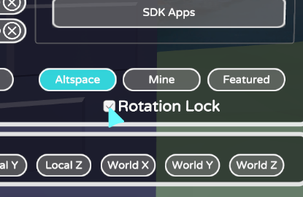

### I updated my template but I was still in the world with that template.

The world only updates once you either leave, re-enter or wait long enough. So for example if you just updated your template and someone joins your world, they will see the updated version but you won’t.

## Mozilla Hubs Problems

### Importing transparent images

For transparent images you have two choices. Either choices can be selected within the image settings once you placed it down. These are called transparency modes. Blend means it can have a bigger range of transparency, while masked means it’ll turn it to a cutout of the alpha values. Fusing transparent images may cause visual problems in mozilla. That’s why I don’t recommend doing it!

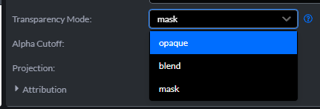

Another cool thing I’ve discovered is that you can create spherical glows if you turn one setting on. Turning the projection to 360-equirectangular will result in it being spherical. This is handy for creating skyboxes or 360 images. Or effects in my case!

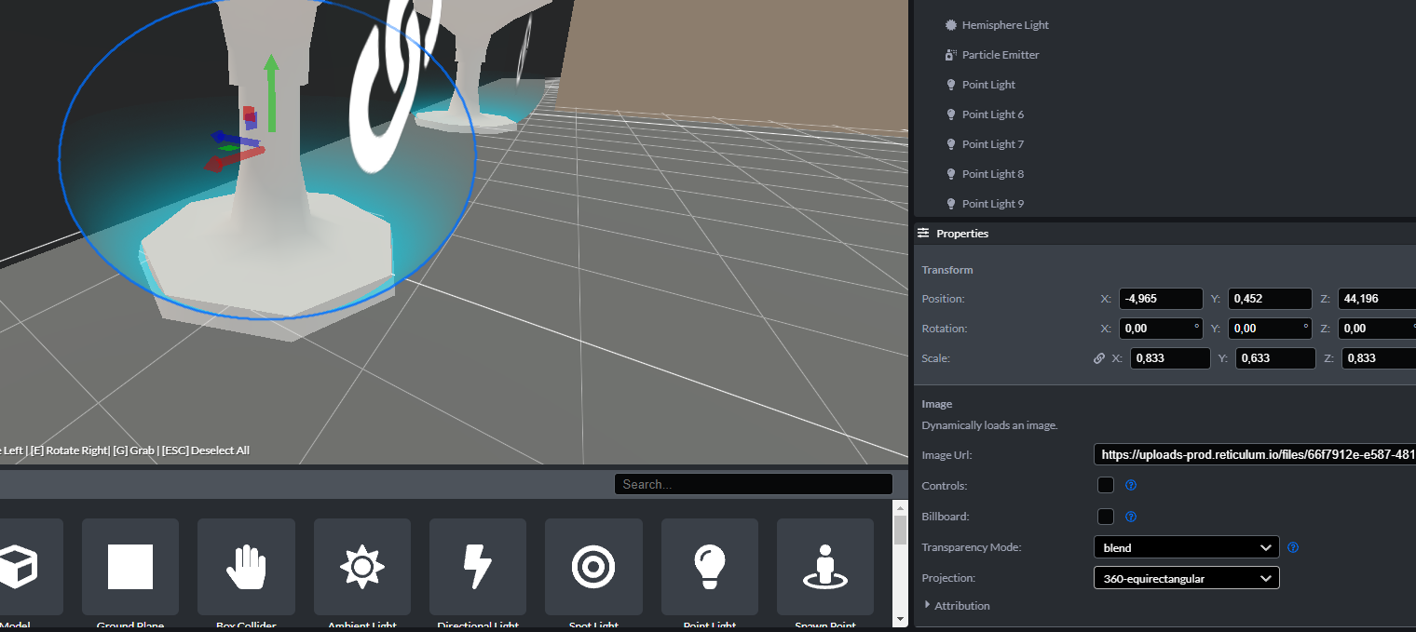

### Importing game models from Maya

Mozilla only accepts GLB files. Glb simply means that it’s a binary version of the 3d-model. Maya sadly does not have the function to export as Glb. A trick I used is to make a model add some base colors to it, and then run it through a converter. I used <https://miconv.com/convert-fbx-to-glb/>

You sadly can’t export textures with your maya model but I believe that you can in blender.

### Non-uniform Scaling

This one is easier than you think. Objects can’t be scaled in a non-uniform matter in world space. You have to switch your transform space to ‘Object’. Can also be done by pressing ‘Z’.

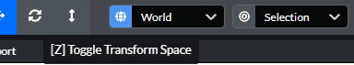

### Make your avatar invisible

In order to make your avatar invisible you have to create an avatar. Then set the base color to a transparent image and voila!

### Disable Nametags

You can disable player name tags in the settings within Mozilla hubs. It is not possible to hide your own tag from others though.

### Players camera moves weird and glitchy

This can only happen if one of the scale values is not uniform. Make sure to switch the values to the same value.

